# CGRA 352 – Assignment 1

300446258

Jackson Tume

*-Brief introduction of your functions in your programs.*

*Core-1 Function:*

Takes a BGR image as a param, converts the image HSV colour space. Then splits the image into separate 3 channels (both BGR and HSV). Then combines the BGR and HSV (complete and separate channels) images into a single large image, to be able to view in one window.

*Core-2 Function:*

Takes a BGR image as a param, converts the image HSV colour space and splits it into 3 separate channels. For each channel scale the image by {0.0, 0.2, 0.4, 0.6, 0.8}. Then merges the separate channel images, back into an HSV image, then converts from HSV to BGR colour space. Then combines all 15 images into a single large image, to be able to view in one window.

*Core-3 Function:*

Takes an image as a param, loops through every single pixel in the and compares it to the pixel value at (80,80). If the threshold is 100 or less, it changes the pixel value to white (255), otherwise changes it to black (0). Returns a grayscale image.

*Completion Function:*

Takes in a grayscale image as a param, passes the grayscale image to 3 different functions (Laplacian, SobelX, SobelY). Combines the three different images into a single large image, to be able to view in a single window. Returns the grayscale, single large image of all 3 functions.

*Completion Laplacian:*

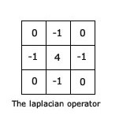Takes in a grayscale image as a param, loops through every pixel, by row and col. Applies the Laplacian filter to each. Converts the image to scale of [0,255]. Returns the image.

*Completion Sobel-X/Y:*

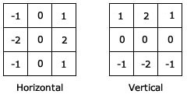Takes in a grayscale image as a param, loops through every pixel, by row and col. Applies the Sobel filter to each pixel. Converts the image to scale of [0,255]. Returns the output image.

*Challenge Function:*

Takes in a grayscale image as a param, loops through every pixel and calculates the histogram. Then finds the first non-zero bin in the histogram and calculates the scale. Initializes and calculates the look up table. Then uses the look up table to apply the histogram equalization onto the original image. Returns a single large image which displays the original and the equalized images.

*-How to run your program to perform the functions required by the assignment.*

In the command line, type in the name of the function to run it,

E.G: typing “core2” will run the Core-2 function, while typing “comp” will run the Completion function and typing “chal” will run the Challenge function.

*-The results of Core 1/2/3, Completion and Challenge.*

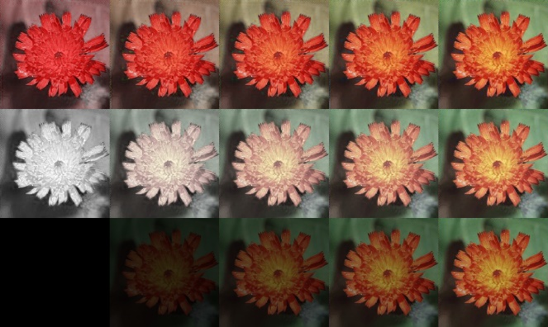

Results of Core-2

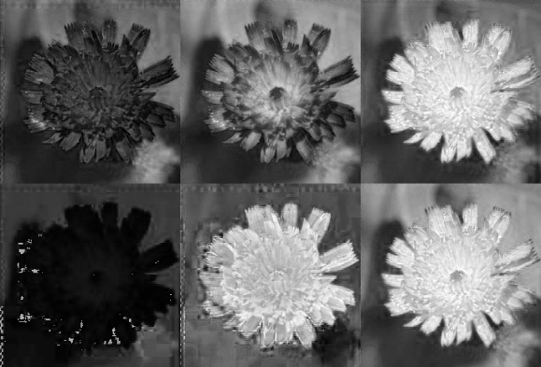

Results of Core-1

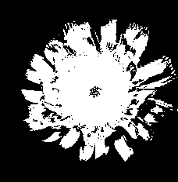

Results of Core-3

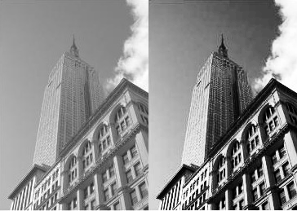

Results of Challenge – Left is original image, Right is Histogram Equalized image

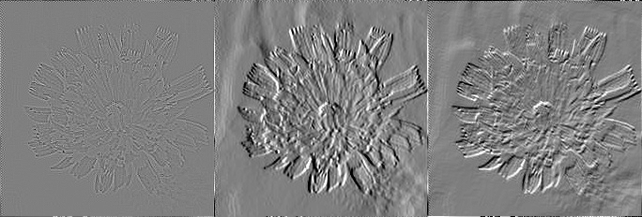

Results of Completion (left to right) Laplacian, Sobel-X, Sobel-Y